**LOCAL UNION 831**

**1155 Corporate Center Drive**

**Monterey Park, CA 91754**

**(626) 296-8086**

**www.local831.org**

**Available for Work:**

**L.A. & S.D. (626) 296-8086**

**TRADESHOW & SIGN CRAFTS**

**I.U.P.A.T – A.F.L.-C.I.O**

|  |  |  |  |  |  |  |
| --- | --- | --- | --- | --- | --- | --- |
| JULY | | | | | | |
| Su M Tu W Th F Sa | | | | | | |
|  |  |  |  |  | 1 | 2 |
| 3 | 4 | 5 | 6 | 7 | 8 | 9 |
| 10 | 11 | 12 | 13 | 14 | 15 | 16 |
| 17 | 18 | 19 | 20 | 21 | 22 | 23 |
| 24 | 25 | 26 | 27 | 28 | 29 | 30 |
| 31 |  |  |  |  |  |  |

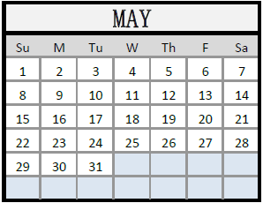

**JUNE 2022**

To pay your dues over the phone, please call the Central Dues department at (626) 296-8054. There is no charge for using a debit card, however there is a charge when using a credit card.

Any questions you may have about your Health and Welfare benefits, call Membership Services at (626) 296-8050.

***Please note: 2nd Quarter Dues have been waived.***

***3rd Quarter Dues will be charged July 1st.***

