LOCAL UNION 831
1155 Corporate Center Drive
Monterey Park, CA 91754
(626) 296-8086
www.local831.org
Available for Work:
L.A. & S.D. (626) 296-8086

TRADESHOW & SIGN CRAFTS
I.U.P.A.T – A.F.L.-C.I.O

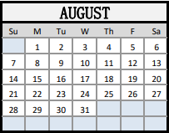 AUGUST 2022 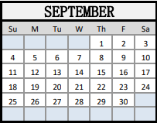

To pay your dues over the phone, please call the Central Dues Department at (626) 296-8054. There is no charge for using a debit card, however there is a charge when using a credit card.

Any questions you may have about your Health and Welfare benefits, call Membership Services at (626) 296-8050.

Please note: 3rd Quarter Dues were charged July 1st.
For any questions please call Local 831 office at (626)-296-8049

