**LOCAL UNION 831**

**1155 Corporate Center Drive**

**Monterey Park, CA 91754**

**(626) 296-8086**

**www.local831.org**

**Available for Work:**

**S.D. (858) 530-0270**

**L.A. (626) 296-8086**

**TRADESHOW & SIGN CRAFTS**

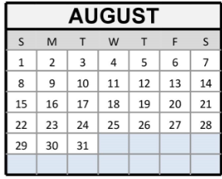**I.U.P.A.T – A.F.L.-C.I.O**

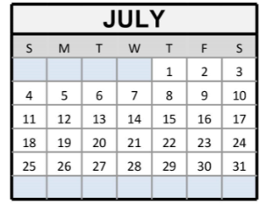

**JULY 2021**

**FOR ASSISTANCE IN APPLYING FOR UNEMPLOYMENT BENEFITS:** [**www.edd.ca.gov**](http://www.edd.ca.gov)



***Please note: 3rd Quarter Dues Have been waived!***

In an effort to assist Local 831 members through this national health crisis the IUPAT, District Council 36 and Local 831 Business Representatives and the Executive Board have approved a waiver of membership dues for the third quarter of 2021 (July, August and September). If you have paid your dues in advance, you will receive three (3) months credit on your dues account.

If you should have any questions, please contact your Business Representatives.

Fraternally,

Steve Bigelow

Assistant Business Manager

Steve Bigelow- (702) 506-7847

Jon Coley (626) 265-9141

Matt Kriz (619) 397-8935