**LOCAL UNION 831**

**1155 Corporate Center Drive**

**Monterey Park, CA 91754**

**(626) 296-8086**

**www.local831.org**

**Available for Work:**

**L.A. (626) 296-8086**

**TRADESHOW & SIGN CRAFTS**

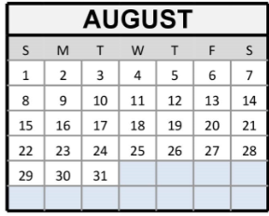**I.U.P.A.T – A.F.L.-C.I.O**

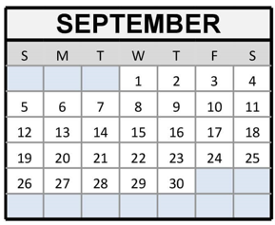

**AUGUST 2021**

**FOR ASSISTANCE IN APPLYING FOR UNEMPLOYMENT BENEFITS:** [**www.edd.ca.gov**](http://www.edd.ca.gov)



***Please note: 3rd Quarter Dues Have been waived!***