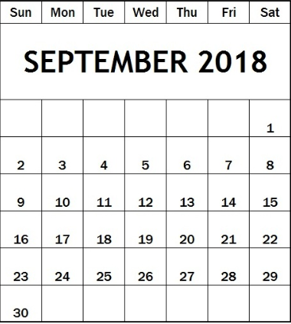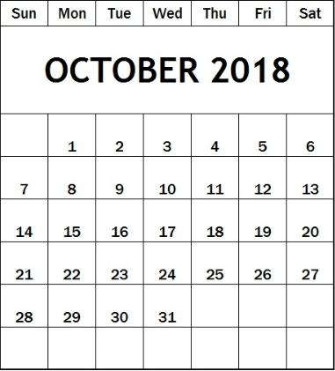**OCTOBER 2018**  
**SHOW SCHEDULE**

**REMINDER!!  
4TH QUARTER DUES  
ARE DUE IN THE MONTH  
OF OCTOBER.**

**For Assistance in applying for Unemployment Benefits:**  
[**http://www.edd.ca.gov/jobs_and training/workforce_partner_information.htm**](http://www.edd.ca.gov/jobs_and%20training/workforce_partner_information.htm)

