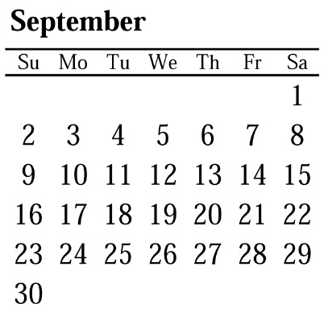**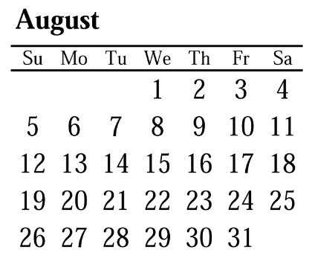AUGUST 2018**  
**SHOW SCHEDULE**

***September 1st Wage Chart***  
***has been sent to Employers***  
***If you need a copy please***  
***Contact the Local (626)296-8086***

|  |  |  |  |  |  |  |
| --- | --- | --- | --- | --- | --- | --- |
| **MOVE IN** | **START** | **END** | **SHOW NAME** | **LOCATION** | **HALL/BOOTH** | **COMPANY** |
| Jul 27 | 07/30 | 08/01 | NCSL LEGISLATIVE SUMMIT | LACC | S 220 | FDC |
| Jul 28 | 07/31 | 08/02 | IEEE | LBCC | 150 | GESLA |
| Jul 30 | 08/01 | 08/02 | ACTIVE & SWIM COLLECTIVE 2018 | ACC | A 300 | FDC |
| Jul 30 | 08/02 | 08/04 | NBM | LBCC | 200 | SHOW READY |
| Aug 01 | 08/04 | 08/05 | CATCON | PASADENA CC | 150 | BLAINE |
| Aug 06 | 08/07 | 08/08 | GOLDCO | SDCC | SAIL 225 | GESSD |
| Aug 06 | 08/07 | 08/10 | ADS INTERNATIONAL | SD MANCHESTER HYATT | 160 | FDC |
| Aug 08 | 08/10 | 08/12 | KCON | LACC | W 300 | SHEPARD |
| Aug 08 | 08/11 | 08/15 | GBTA CONVENTION 2018 | SDCC | **C-H 900** | FDC |
| Aug 13 | 08/15 | 08/16 | SPECIALTY ADVERTISING ASSN | LBCC | 300 | GESLA |
| Aug 15 | 08/17 | 08/19 | ANAHEIM HOME & GARDEN SHOW | ACC | D 200 | BLAINE |
| Aug 15 | 08/17 | 08/19 | POWER MORPHICON | ACC | NORTH 240 | GESLA |
| ***\*\*\*AUGUST 15TH (WED) GENERAL MEMBERSHIP / STEWARD MEETING / 6:00PM / UFCW HALL / 8530 STANTON AVE, BUENA PARK\*\*\**** | | | | | | |
| Aug 16 | 08/18 | 08/19 | FABRICARE | LBCC | 100 | GESLA |
| Aug 16 | 08/19 | 08/21 | WESTERN FOOD SERVICE | LACC | S 440 | FREEMAN |
| Aug 17 | 08/21 | 08/23 | SPIE OPTICS | SDCC | 185 | FDC |
| Aug 17 | 08/21 | 08/23 | HARLEY DAVIDSON DEALER MEETING | SDCC | 275 | FDC |
| Aug 18 | 08/19 | 08/21 | NCAD | DISNEY HOTEL | 130 | INNOVATIVE |
| Aug 23 | 08/25 | 08/26 | THE FIT EXPO | ACC | B&C 225 | BLAINE |
| Aug 26 | 08/27 | 08/28 | CALIFORNIA HR CONFERENCE | LBCC | 200 | BLAINE |
| Aug 27 | 08/28 | 08/30 | TEEC | SD HILTON BAYFRONT | 125 | GESSD |
| Aug 29 | 08/30 | 08/31 | BIG INDUSTRY SHOW | LACC | S 325 | BLAINE |
| Aug 29 | 09/06 | 09/08 | CEDIA | SDCC | **FULL FACILITY** | SHEPARD |
| Aug 30 | 08/31 | 09/02 | SCRC 2018 | ACC | 110 | BLAINE |
| Sep 02 | 09/05 | 09/06 | PACIFIC OIL CONFERENCE | JW MARRIOTT | 110 | GESLA |
| ***\*\*\*SEPTEMBER 3RD (MONDAY) UNION HOLIDAY / LABOR DAY\*\*\**** | | | | | | |
| Sep 04 | 09/04 | 09/08 | LONG BEACH COIN | LBCC | 350 | GESLA |
| Sep 04 | 09/05 | 09/07 | CWCRC | MONARCH BEACH RESORT | 100 | TRICORD |
| Sep 04 | 09/05 | 09/08 | ASCA ANNUAL CLINIC | ANAHEIM MARRIOTT | 130 | GESLA |
| Sep 06 | 09/12 | 09/14 | MOBILE WORLD CONGRESS | LACC | **W 700** | FDC |
| Sep 10 | 09/12 | 09/13 | SOUTHERN CALIFORNIA DESIGN | LBCC | 190 | SHEPARD |
| Sep 11 | 09/12 | 09/14 | LEAGUE OF CALIFORNIA CITIES | LBCC | 270 | GESLA |

**For Assistance in applying for Unemployment Benefits:**  
[**http://www.workforcedevelopmentmonth.com/workforce_experts_lacounty.asp**](http://www.workforcedevelopmentmonth.com/workforce_experts_lacounty.asp)